**NAME:- SRISHTI GOYAL**

**ROLL NO:- 24csu206**

ASSIGNMENT-3

QUES- Simple Calculator is a C language-based application used for performing all the simple arithmetic operations like addition, multiplication, division, and subtraction. The application can be made using basic knowledge of C like if-else statements, loops, etc.

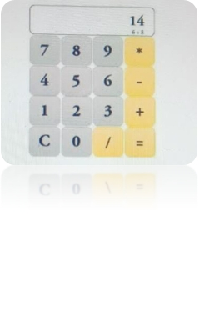The functionalities of the application are mentioned below:

1. Addition

2. Subtraction

3. Multiplication

4. Division

5. Logarithmic values

6. Square roots

SOL:- #include <stdio.h>

#include <math.h>

void displayMenu() {

printf("\nSimple Calculator\n");

printf("1. Addition\n");

printf("2. Subtraction\n");

printf("3. Multiplication\n");

printf("4. Division\n");

printf("5. Logarithm (base e)\n");

printf("6. Square Root\n");

printf("7. Exit\n");

printf("Choose an option (1-7): ");

}

int main() {

int choice;

double num1, num2, result;

do {

displayMenu();

scanf("%d", &choice);

switch (choice) {

case 1:

printf("Enter two numbers: ");

scanf("%lf %lf", &num1, &num2);

result = num1 + num2;

printf("Result: %.2lf\n", result);

break;

case 2:

printf("Enter two numbers: ");

scanf("%lf %lf", &num1, &num2);

result = num1 - num2;

printf("Result: %.2lf\n", result);

break;

case 3:

printf("Enter two numbers: ");

scanf("%lf %lf", &num1, &num2);

result = num1 * num2;

printf("Result: %.2lf\n", result);

break;

case 4:

printf("Enter two numbers: ");

scanf("%lf %lf", &num1, &num2);

if (num2 != 0) {

result = num1 / num2;

printf("Result: %.2lf\n", result);

} else {

printf("Error: Division by zero is undefined.\n");

}

break;

case 5:

printf("Enter a number: ");

scanf("%lf", &num1);

if (num1 > 0) {

result = log(num1);

printf("Logarithm (base e) of %.2lf: %.2lf\n", num1, result);

} else {

printf("Error: Logarithm is undefined for non-positive numbers.\n");

}

break;

case 6:

printf("Enter a number: ");

scanf("%lf", &num1);

if (num1 >= 0) {

result = sqrt(num1);

printf("Square root of %.2lf: %.2lf\n", num1, result);

} else {

printf("Error: Square root is undefined for negative numbers.\n");

}

break;

case 7:

printf("Exiting the calculator. Goodbye!\n");

break;

default:

printf("Invalid choice. Please choose a number between 1 and 7.\n");

}

} while (choice != 7);

    return 0;

}